Functional Requirement Document
For
District Administration, Gurugram

Table of Contents
1. INTRODUCTION: 3
PURPOSE: 3
BACKGROUND: 3
2. Proposed Solution for tracking asset. 5
3. System Design: 5
4. Workflow 7
5. ER Diagram 10
6. Screens: 11

INTRODUCTION:

PURPOSE: The purpose of this solution is to automate the process of raising request for
items (stationery/IT related) and services provided by District Administration, Gurugram. There are two departments namely DITS and NAZAR, which are responsible for fulfilling the requirement related to infrastructure, stationary, service & maintenance by different department.

Proposed Solution for tracking asset.
Proposed system is a software application which avoids more manual hours that need to spend in record keeping and generating reports. This application keeps the data in a centralized way which is available to all the users simultaneously. It is very easy to manage historical data in database. No specific training is required for the employees to use this application. They can easily use the tool that decreases manual hours spending for normal things and hence increases the performance. As the data is centralized it is very easy to maintain the stocks of the various items in all godowns.

Advantages:
• Easy to manage all the daily transactions
• Can generate required reports easily
• Easy to manage historical data in a secure manner
• Centralized database helps in avoiding conflicts
• Easy to use web application that does not requires specific training

System Design:

The System is designed with concept of master data & Transactional data. Master data is comprising of all the data which will hardly change or need to be updated like building, floors, Item category, Users This is all master related data will be maintained by Admin user. Transaction data is basically comprising of all the transaction that will be executed on the base of master data, transactional data include service request, item request etc.

The major functionality of this product is divided into three categories.
- Administrative user module
- DITS user module
- NAJAR user module

Admin Module: This module will be responsible for overall administration of the web application. This module will be responsible for creating new category of items and updating the current stock as and when required. Basic task perform by Admin module are:

- Create new users
- Change the password
- Add/Update the Department
- Add/Update the information about the centralised store (DITS/NAJAR)
- Can view the information about the Inwards
- Can view the information about the item issue/dispatch.
- Can view/generate MIS reports.

DITS Module: This module will be specific to DITS department. All the request which are raised by user to DITS department will be received under this module. As per received request, DITS authorized user will check the availability of required items with him physically and accordingly update the request form.

This module will basically take care of the need of stationary and IT related items.

NAJAR Module: This module will be specific to NAJAR department. All the request which are raised by user to NAJAR department will be received under this module. As per received request, NAJAR authorized user will check the availability of required items/services with him and accordingly update the request form.

This module will basically take care of the need of Service & maintenance.

Workflow

The type of request generally raised to the Admin user is for creating user id, department id, item category. Other than Master data creation, Admin user have to manage MIS reports as well.

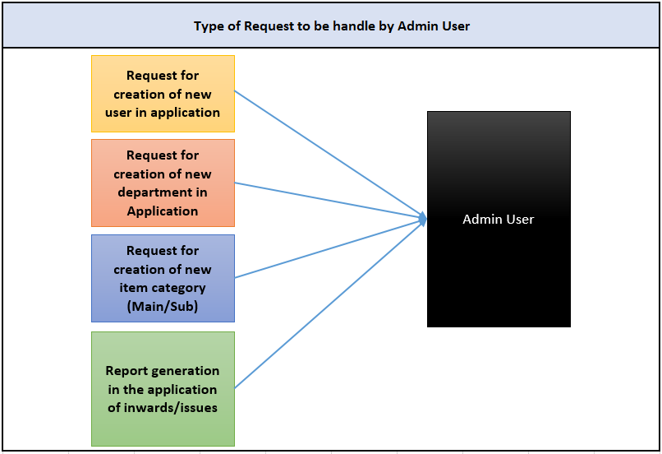

Proposed Workflow for the new item request form by user with the help of application:

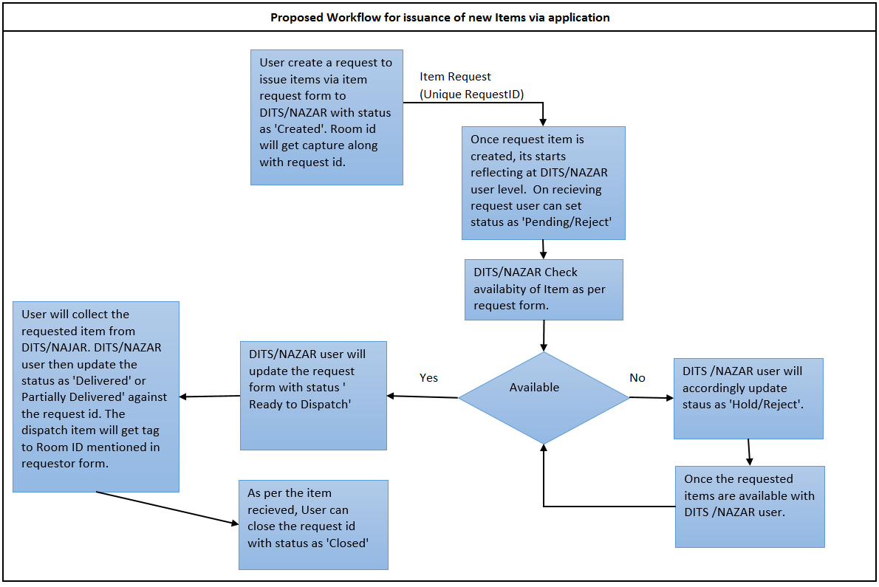

Proposed Workflow for the Service/Maintenance request form by user with the help of application

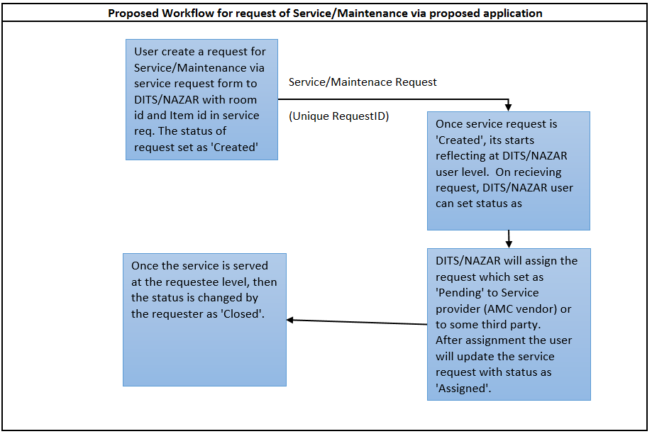

ER Diagram

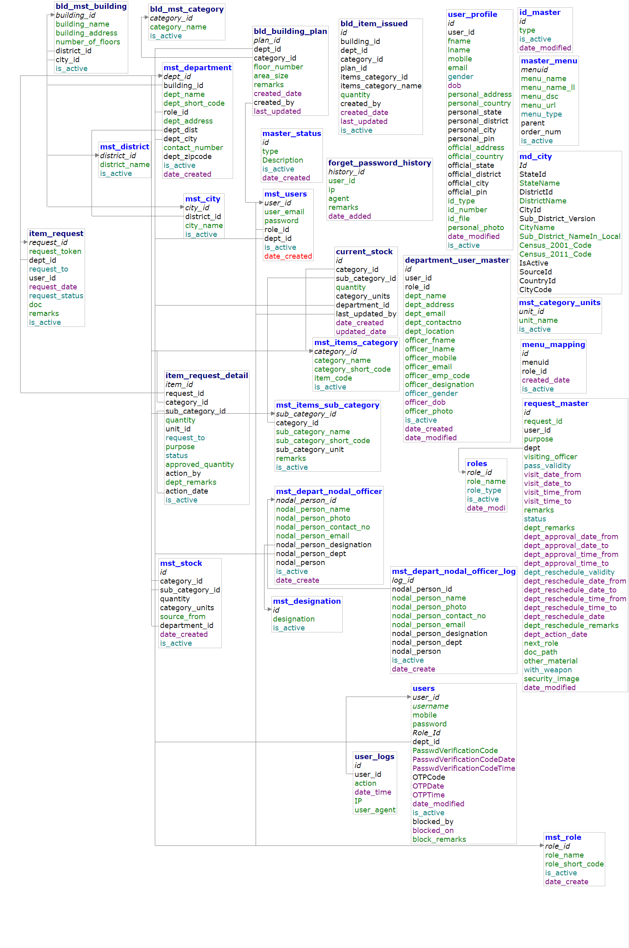

Screens:

